Net 1061 Switching, Routing, and Wireless Essentials

Name:

Lab: #

Follow the instructions down below for the lab itself. For this lab, all answers need to be in blue font. For the questions right below, answer in complete sentences. If this is a self-grading packet tracer. Ensure you paste the screen shot of your score page at the bottom of the document. You will upload both this document and the pkt file regardless if it is self-grading or not. Let the instructor know if you have any questions.

Lab Analysis Report

1. Using complete sentences summarize work you completed during the lab.
In this lab, I enabled port security on the switch for f0/1-2. Then, I added a Mac address maximum. Then, I set it to sticky mode and set the violation to restrict. Finally, I verified that only one mac address was able to be used on a port.

2. Using complete sentences describe what you learned from the lab. Hint; look at the lab objectives listed at the top of the lab section.
In this lab, I learned how port security works and how you can limit the number of devices that can connect to a port and send packets.

Problems Encountered

1. Using complete sentences describe any problem(s) experienced during lab.
I didn’t experience any problems.

2. Using complete sentences describe how you solved your problem(s).

3. Using complete sentences explain if you needed any assistance with the lab; then list what you learned from that assistance.

Packet Tracer - Implement Port Security

Addressing Table
Device | Interface | IP Address | Subnet Mask
S1 | VLAN 1 | 10.10.10.2 | 255.255.255.0
PC1 | NIC | 10.10.10.10 | 255.255.255.0
PC2 | NIC | 10.10.10.11 | 255.255.255.0
Rogue Laptop | NIC | 10.10.10.12 | 255.255.255.0

Objective
Part 1: Configure Port Security
Part 2: Verify Port Security

Background
In this activity, you will configure and verify port security on a switch. Port security allows you to restrict a port’s ingress traffic by limiting the MAC addresses that are allowed to send traffic into the port.

Configure Port Security
    - Access the command line for S1 and enable port security on Fast Ethernet ports 0/1 and 0/2.
Open Configuration Window
S1(config)# interface range f0/1 – 2
S1(config-if-range)# switchport port-security
    - Set the maximum so that only one device can access the Fast Ethernet ports 0/1 and 0/2.
S1(config-if-range)# switchport port-security maximum 1
    - Secure the ports so that the MAC address of a device is dynamically learned and added to the running configuration.
S1(config-if-range)# switchport port-security mac-address sticky
    - Set the violation mode so that the Fast Ethernet ports 0/1 and 0/2 are not disabled when a violation occurs, but a notification of the security violation is generated and packets from the unknown source are dropped.
S1(config-if-range)# switchport port-security violation restrict
    - Disable all the remaining unused ports. Use the range keyword to apply this configuration to all the ports simultaneously.
S1(config-if-range)# interface range f0/3 - 24 , g0/1 - 2
S1(config-if-range)# shutdown

Verify Port Security
    - From PC1, ping PC2.
    - Verify that port security is enabled and the MAC addresses of PC1 and PC2 were added to the running configuration.
S1# show run | begin interface
    - Use port-security show commands to display configuration information.
S1# show port-security
S1# show port-security address
    - Attach Rogue Laptop to any unused switch port and notice that the link lights are red.
    - Enable the port and verify that Rogue Laptop can ping PC1 and PC2. After verification, shut down the port connected to Rogue Laptop.
    - Disconnect PC2 and connect Rogue Laptop to F0/2, which is the port to which PC2 was originally connected. Verify that Rogue Laptop is unable to ping PC1.
    - Display the port security violations for the port to which Rogue Laptop is connected.
S1# show port-security interface f0/2
Close Configuration Window

Question:
How many violations have occurred?
There are 5 violations.your answers here.
    - Disconnect Rouge Laptop and reconnect PC2. Verify PC2 can ping PC1.

Question:
Why is PC2 able to ping PC1, but the Rouge Laptop is not?
PC2’s Mac address is learned in the system and there can only be one Mac address at a time on the port.
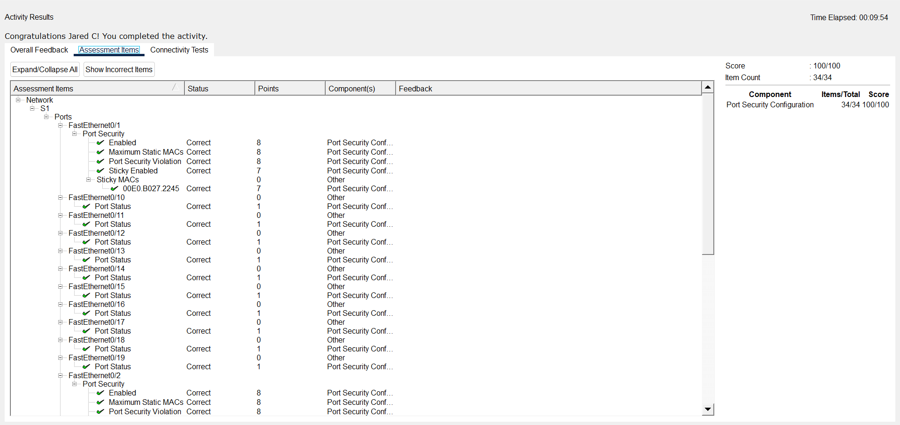Type your answers here.
End of Document

